CREATE DATABASE Com_db;
USE Com_db;

CREATE TABLE employees(
emp_id INT PRIMARY KEY,
first_name VARCHAR(50),
last_name VARCHAR(50),
department VARCHAR(30),
salary int);

INSERT INTO employees VALUES
(1,'Alice','Johenson','HR',50000),
(2,'Bob','Smith','IT',60000),
(3,'Charlie','Brown','Finance',55000),
(4,'David','Lee','IT',70000),
(5,'Eva','Green','HR',48000);

SELECT*FROM employees;
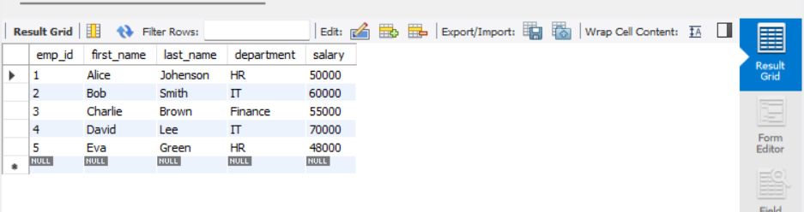

UPDATE employees
SET salary = salary + 5000
WHERE department = 'HR';

SELECT emp_id, first_name, department, salary FROM employees;
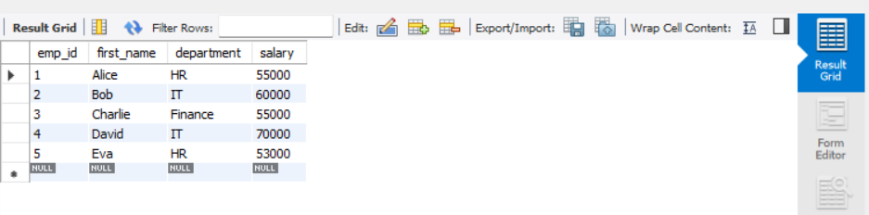
DELETE FROM employees
where emp_id=5;

SELECT *FROM employees;
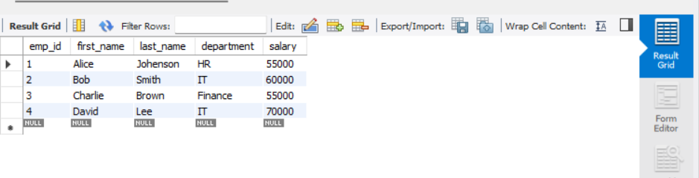
SELECT * FROM employees
WHERE first_name LIKE 'A%';
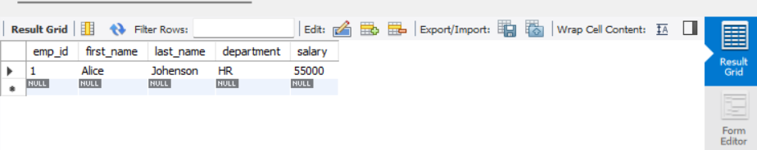
SELECT
UPPER(first_name) AS upper_name,
CONCAT(first_name,' ',last_name) AS full_name,
LENGTH(first_name) AS name_length
FROM employees;
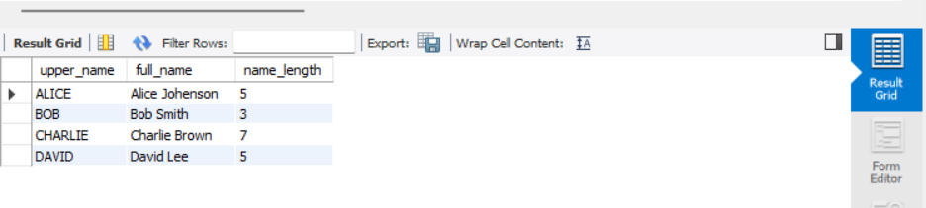
CREATE TABLE managers (
emp_id INT,
first_name VARCHAR(50)
);

INSERT INTO managers VALUES
(2,'Bob'),
(6,'Frank');

SELECT first_name FROM employees
UNION
SELECT first_name FROM managers;
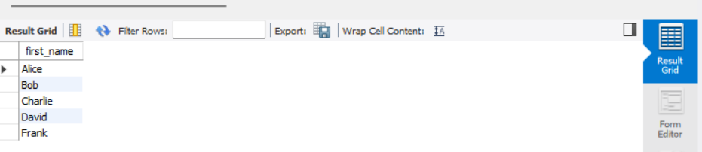
CREATE USER 'user1'@'localhost' IDENTIFIED BY '1234';
GRANT SELECT, INSERT ON company_db.employees TO 'user1'@'localhost';
REVOKE INSERT ON company_db.employees FROM 'user1';

START TRANSACTION; UPDATE employees
SET salary = salary + 2000
WHERE emp_id = 1; COMMIT;


START TRANSACTION;
DELETE FROM employees WHERE emp_id = 3;
ROLLBACK;

SELECT * FROM employees WHERE emp_id = 3;SELECT emp_id, first_name, salary FROM employees;

START TRANSACTION;
UPDATE employees SET salary = 80000 WHERE emp_id = 2;
SAVEPOINT before_delete;
DELETE FROM employees WHERE emp_id = 4;
ROLLBACK TO before_delete;
COMMIT;

SELECT emp_id, first_name, salary FROM employees;

